LAB Two – Project Requirements

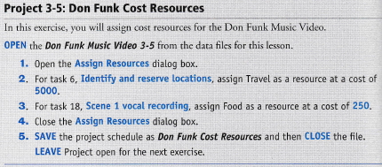



Yan Li has 3 days worked in the week April 24th – May 1st of 2016. In those 3 days, he worked 42 hours which is over the normal 40 per week. What we can do is split his days so he doesn’t have to stay 16 hours’ day at work, that can take away his focus on work. I don’t think it is a big deal he has 2 hours’ overtime but next time maybe he can split his hours different so he can work normal and still stay in the 40 hours he has to do in a week, because working 16 hour days can take away your focus on work and the tasks you have to do.